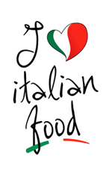Oak Crest Community Dinner
Monday May 21st at 6pm

Our Italian Night will feature chef JP’s homemade marinara, pasta and meatballs with a surprise and a special dessert.

Reservations are requested call 8477422255
$12. Donation is requested

